Recipe for Jeevamritham and Panchagavya Preparation

# Recipe for Jeevamritham preparation

The ingredients that go into its making are

1. Organic Dhal flour (Besan): 2kg,

2. Organic Unprocessed Jaggery: 2Kg,

3. Cow urine (Native Cow): 5-10 liters

4. Cow Dung (Native Cow): 10kg

5. Anthill soil and virgin soil: handful all mixed one after the other and fermented in water.

6. 200 liters of water

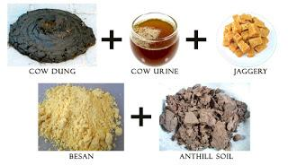

# Application:

The ingredients are stirred 3 times daily and Leave the entire mixture to ferment for 48hours covered by a cloth.

Apply 10% filtered Jiwamrita on the crops and trees. (Ref [1] says, As a rule the entire mixture has to be used by the 10th or the 12th day.)

## Filtering:

Drip Irrigation

Amrutha Farms

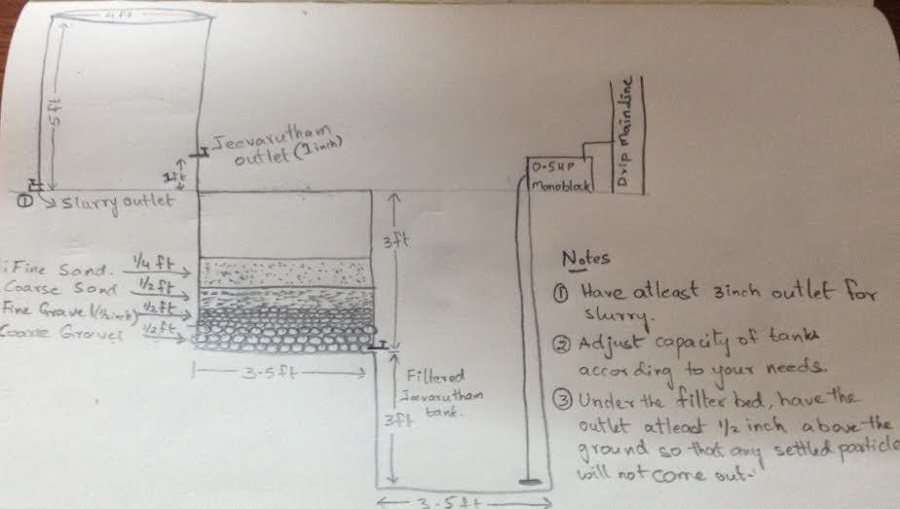

# References:

[1] Suleka: <http://creative.sulekha.com/jeevamrutham-the-elixir-for-modern-day-agriculture_629589_blog>

[2] Palekar: <http://palekarzerobudgetspiritualfarming.org/jiwamrita.aspx>

[3] Kissanji: <http://www.kisaanji.com/how-to-prepare-drava-jeevamrutham/>

[4] Slideshare: <https://www.slideshare.net/GYANENDRAMAURYA2/zero-budget-natural-farming>

[5] Amrutha Farms: <http://amruthafarms.blogspot.in/>

[6] Jeevamritham through drip: <https://discuss.farmnest.com/t/jeevamrutham-through-drip/886>

[7] Detailed recipe: <http://naturalfarming4life.blogspot.in/p/padma-shri-subhash-palekars-zero-budget.html>

# Recipe for Panchagavya Preparation (Taken from the internet)

## 1. Ingredients

Panchagavya, an organic product has the potential to play the role of promoting growth and providing immunity to the plant system. Panchagavya consists of nine products viz. cow dung, cow urine, milk, curd, jaggery, ghee, banana, Tender coconut, and water. When suitably mixed and used, these have miraculous effects.

Cow dung - 7 kg

Cow ghee - 1 kg

Mix the above two ingredients thoroughly both in the morning and evening hours and keep it for 3 days

Cow Urine - 10 liters

Water - 10 liters

After 3 days mix cow urine and water and keep it for 15 days with regular mixing both in morning and evening hours. After 15 days, mix the following and the panchagavya will be ready after 30 days.

Cow milk - 3 liters

Cow curd - 2 liters

Tender coconut water - 3 liters

Jaggery - 3 kg

Well ripened poovan banana – 12 nos.

## 2. Preparation

All the above items can be added to a wide-mouthed mud pot, concrete tank, or plastic can as per the above order. The container should be kept open under shade. The content is to be stirred twice a day both in morning and evening. The Panchagavya stock solution will be ready after 30 days. (Care should be taken not to mix buffalo products. The products of local breeds of cow is said to have potency than exotic breeds). It should be kept in the shade and covered with a wire mesh or plastic mosquito net to prevent houseflies from laying eggs and the formation of maggots in the solution. If sugarcane juice is not available add 500 g of jaggery dissolved in 3 liter of water.

| **Ingredients of Panchagavya** | | | | |
| --- | --- | --- | --- | --- |
| http://agritech.tnau.ac.in/org_farm/images/spl_intput/pan_cow_dung.png | http://agritech.tnau.ac.in/org_farm/images/spl_intput/pan_cow_urine.png | http://agritech.tnau.ac.in/org_farm/images/spl_intput/pan_ghee.png | http://agritech.tnau.ac.in/org_farm/images/spl_intput/pan_milk.png | http://agritech.tnau.ac.in/org_farm/images/spl_intput/pan_water.png |
| **Cow dung** | **Cow urine** | **Cow ghee** | **Milk** | **Water** |
| | http://agritech.tnau.ac.in/org_farm/images/spl_intput/pan_curd.png | http://agritech.tnau.ac.in/org_farm/images/spl_intput/pan_jaggery.png | http://agritech.tnau.ac.in/org_farm/images/spl_intput/pan-coconut.png | http://agritech.tnau.ac.in/org_farm/images/spl_intput/pan-banana.png | | --- | --- | --- | --- | | **Cow curd** | **Jaggery** | **Tender Coconut** | **Well ripened poovan banana** | | | | | |

Physio-chemical and biological properties of Panchagavya

**Chemical composition**

pH: 5.45

EC dSm2: 10.22

Total N (ppm): 229

Total P (ppm): 209

Total K (ppm): 232

Sodium: 90

Calcium: 25

IAA (ppm): 8.5

GA (ppm): 3.5

**Microbial Load**

Fungi: 38800/ml

Bacteria: 1880000/ml

Lactobacillus: 2260000/ml

Total anaerobes: 10000/ml

Acid formers: 360/ml

Methanogen: 250/ml

Physico-chemical properties of Panchagavya revealed that they possess almost all the major nutrients, micro nutrients and growth harmones (IAA & GA) required for crop growth. Predominance of fermentative microorganisms like yeast and lactobacillus might be due to the combined effect of low pH, milk products and addition of jaggery/sugarcane juice as substrate for their growth.

The low pH of the medium was due to the production of organic acids by the fermentative microbes as evidenced by the population dynamics and organic detection in GC analysis. Lactobacillus produces various beneficial metabolites such as organic acids, hydrogen peroxide and antibiotics, which are effective against other pathogenic microorganisms besides its growth. GC-MS analysis resulted in following compounds of fatty acids, alkanes, alconol and alcohols.

## 3. Beneficial effects of Panchagavya on commercial crops

### Mango

Induces dense flowering with more female flowers

Irregular or alternate bearing habit is not experienced and continues to fruit regularly

Enhances keeping quality by 12 days in room temperature

Flavour and aroma are extraordinary

### Acid lime

Continuous flowering is ensured round the year

Fruits are plumpy with strong aroma

Shelf life is extended by 10 days

### Guava

Higher TSS

Shelf life is extended by 5 days

### Banana

In addition to adding with irrigation water and spraying, 3% solution (100 ml) was tied up at the naval end of the bunch after the male bud is removed. The bunch size becomes uniform. One month earlier harvest was witnessed. The size of the top and bottom hands was uniformly big.

### Turmeric

Enhances the yield by 22%

Extra long fingers

Ensure low drainage loss

Narrows the ratio of mother and finger rhizomes

Helps survival of dragon fly, spider etc which in turn reduce pest and disease load

Sold for premium price as mother/seed rhizome

Enriches the curcumin content

### Jasmine

Exceptional aroma and fragrance

No incidence of bud worm

Continuous flowering throughout the year

### Vegetables

Yield enhancement by 18% and in few cases like Cucumber, the yield is doubled

Wholesome vegetables with shiny and appealing skin

Extended shelf life

Very tasty with strong flavour

Generally panchagavya is recommended for all the crops as foliar spray at 30 % level (3 litre panchagavya in 100 litres of water).

## 4. Recommended dosage

### Spray system

3% solution was found to be most effective compared to the higher and lower concentrations investigated. Three litres of Panchagavya to every 100 litres of water is ideal for all crops. The power sprayers of 10 litres capacity may need 300 ml/tank. When sprayed with power sprayer, sediments are to be filtered and when sprayed with hand operated sprayers, the nozzle with higher pore size has to be used.

### Flow system

The solution of Panchagavya can be mixed with irrigation water at 50 litres per hectare either through drip irrigation or flow irrigation

### Seed/seedling treatment

3% solution of Panchagavya can be used to soak the seeds or dip the seedlings before planting. Soaking for 20 minutes is sufficient. Rhizomes of Turmeric, Ginger and sets of Sugarcane can be soaked for 30 minutes before planting.

### Seed storage

3% of Panchagavya solution can be used to dip the seeds before drying and storing them.

## Periodicity

Pre flowering phase: Once in 15 days, two sprays depending upon duration of crops

Flowering and pod setting stage: Once in 10 days, two sprays

Fruit/Pod maturation stage: Once during pod maturation

### Time of application of Panchagavya for different crops is given as follows

Crops Time schedule

Rice 10,15,30 and 50th days after transplanting

Sunflower 30,45 and 60 days after sowing

Black gram Rainfed: 1st flowering and 15 days after flowering

Irrigated: 15, 25 and 40 days after sowing

Green gram 15, 25, 30, 40 and 50 days after sowing

Castor 30 and 45 days after sowing

Groundnut 25 and 30th days after sowing

Bhendi 30, 45, 60 and 75 days after sowing

Moringa Before flowering and during pod formation

Tomato Nursery and 40 days after transplanting: seed treatment with 1 % for 12 hrs

Onion 0, 45 and 60 days after transplanting

Rose At the time of pruning and budding

Jasmine Bud initiation and setting

Vanilla Dipping setts before planting

References:

[1] TNAU: <http://agritech.tnau.ac.in/org_farm/orgfarm_panchakavya.html>